TMT/MV Industrial/S0432/2025 21 -08- 25

To,
Shankar
Company : MV Industrial Corporation
Mobile No : +918147680399
Email : mvic@mvindustrial.in
City : 'Bengaluru'
State : Karnataka

Dear sir,

Sub :- Supply of HYDRAULIC PRESS BRAKE MACHINE.

Thank you very much for your enquiry regarding your requirement of hydraulic press brake. We are glad to inform you that we would be in a position to supply you the required equipment. Given below are the required specifications and description of the machine and our terms and conditions.

PRESS BRAKE :

1) Size : 2000 X 5 M.M.

2) Tonnage : 100 M.T.

S No | Description of the unit | Offer
1. | Hydraulic Press Brake with bending capacity 2.0 Meters and 5 mm MS Sheet, 100 MT load capacity with Power pack of 7.5HP motor along with one set Standard Die and Punch. | Rs 6,50,000/-

SPECIFICATIONS FOR THE HYDRAULIC PRESS BRAKE MACHINE WITH 2000 M.M. WIDTH AND 6 M.M. THICKNES.

1. Tonnage : 100 M.T.

2. Clearance between Housings : 2000 M.M.

3. Bending capacity in M.S. : 2000 x 5 M.M.

4. Ram stroke. : 150 M.M.

5. Open height. : 350 M.M.

6. Closed height. : 200 M.M.

7. Depth of Throat. : 300 M.M.

- Ram speeds.

a) Approach. : 22 M.M. per Sec.

b) Pressing. : 3 M.M. per Sec.

c) Return. : 40 M.M. per Sec.

9. Motor capacity. : 7.5 H.P. (Crompton)

10. Punch. :2000 x 185 x 45 M.M.

11. Bed size. : 2000 x 175 x 40 M.M.

12. Cost of Machine. : Rs 6,50,000/- + Taxes.

13. Mode of payment. : As per the quotation.

14. Delivery. : As per the quotation.

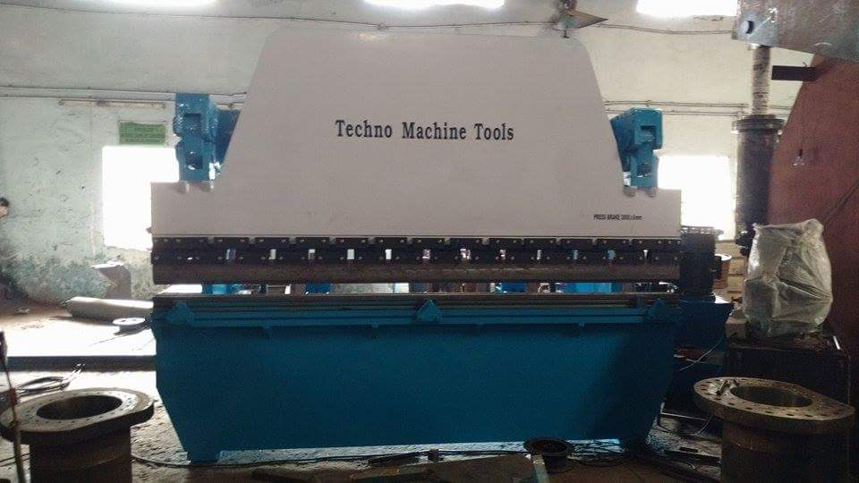

For TECHNO MACHINE TOOLS

( T. SIVARAMA KRISHNA.)

TMT/MV Industrial/S0432/2025 21 -08- 2025

To,
Shankar
Company : MV Industrial Corporation
Mobile No : +918147680399
Email : mvic@mvindustrial.in
City : 'Bengaluru'
State : Karnataka

Dear sir,

Sub :- Supply of 20 MT C-TYPE HYDRAULIC PRESS.

This is reference to your enquiry for the hydraulic press; we offer our least possible price as under.

C TYPE PRESS :

1) Tonnage : 20 MT.

S No | Description of the unit | Offer/unit
1. | C Type Hydraulic Press with capacity 20 Tons. with Power pack of 5 HP motor and with complete electrical.  Clear pass 350 mm  Hydraulic power pack along with motor 5 hp motor  Tank 100 lts  Yuken vane pump 12 lpm  Pressure guage 1 No  Level indicator 1 No  Section filter 1 No  Return line filter 1 No  Section strainer 1 no  Manifold block 1 no  Pressure control valve 1 no  Solenoid operated direction control valve 1 no s  Pipes and fittings.  Bell housing 1 no  Pressure guage 0-250 kg 1 no  Flexible houses 2 nos  Nylon gear coupling 1 no | Rs 2,50,000/-
2 | For Hole punching die extra | Rs 25,000

SPECIFICATIONS FOR THE HYDRAULIC PRESS MACHINE WITH 20 Ton

1. Tonnage : 20 M.T.

2. Clearance between Housings : 350mm

3. Daylight : 430 mm

4. Ram stroke. : 200 M.M.

5. Open height. : 530 M.M.

6. Closed height. : 330 M.M.

7. Depth of Throat. : 250 M.M.

- Ram speeds.

a) Approach. : 12 M.M. per Sec.

b) Pressing. : 2 M.M. per Sec.

c) Return. : 20 M.M. per Sec.

9. Motor capacity. : 5 H.P. (Crompton)

10. Bed size. : 350 x 450 M.M.

12. Cost of Machine. : Rs.2, 50,000/- + Taxes.

13. Mode of payment. : As per the quotation.

14. Delivery. : As per the quotation.

GENERAL TERMS & CONDITIONS:

1 Price quoted per unit ex-work. Hyderabad.
2 Following charges are additional to your account.
- Freight Charge : As actual to be borne by you.
- Sales Tax : 18 % GST.
- Packing charge : As actual to be borne by you.
- Insurance : As actual to be borne by you.
3. Payment : 50% advance along with order another 25%
advance after 3 weeks from first advance and
balance before delivery but after inspection at our
works.
- Delivery : 5-6 weeks from date of techno-commercially clear
purchase order.
- Validity : One month from the date of submission.
- Inspection : Inspection at our works prior to dispatch.
- Warranty : The machine is warranted for a period of 12
months from the date of dispatch against any
manufacturing defects/faulty material or bad
workmanship of any part or component but not
against any kind of abnormal or improper use of
machine. Defective part or component will be
replaced or repaired free of cost. Electrical
components are outside the scope of this
warranty.
- Commissioning : Erection & commissioning done by you, but if
required technical support & guidance provide by
us at additional cost.

NOTE:

- Oil is not in scope of our supply.
- Raw material for trial is arranged by you at your cost.

We are sure you will find our offer in line with your requirements. Should you require any further clarification please call us on mobile number 9246221106.

Thanking you and assuring you of our best services.

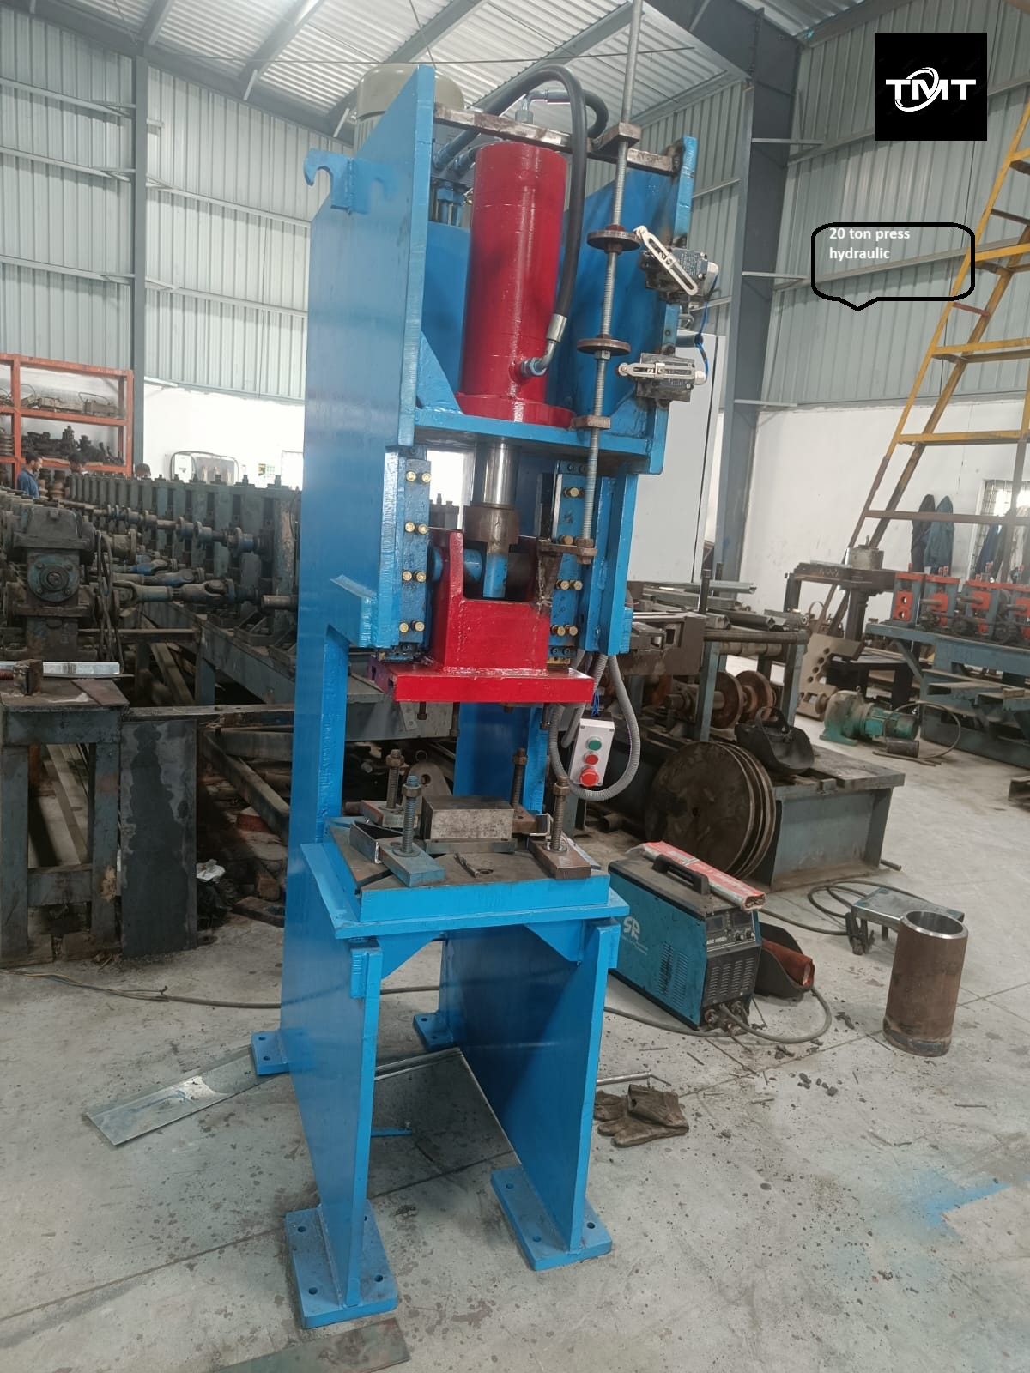

For TECHNO MACHINE TOOLS

T.SIVARAMAKRISHNA

TMT/ MV Industrial Corporation/S0432/2025 21 -08- 2025

To,
Shankar
Company : MV Industrial Corporation
Mobile No :+918147680399
Email : mvic@mvindustrial.in
City : 'Bengaluru'
State : Karnataka

Dear sirs,

Sub: - QUOTATION FOR HYDRAULIC SHEARING MACHINE

Thank you very much for your enquiry regarding your requirement of Hydraulic Shearing Machine mainly for MS Sheets. We are glad to inform you that we would be in a position to supply you the required equipment. Given below are the required specifications and description of the machine and our terms and conditions.

S No | Description of the unit | Offer
1. | Hydraulic shearing machine with fixed rake angle and shearing capacity 1.2 Meters and 5 mm MS Sheet, along with Power pack 5 HP motor and other electrical fittings. With manual back gauge | Rs 3,80,000/-  (Rupees Three Lakhs Eighty Thousand Only)

SPECIFICATIONS FOR THE HYDRAULIC SHEARING MACHINE WITH CUTTING CAPACITY 1200 M.M. WIDTH AND 5 M.M. THICKNESS.

1. CUTTING CAPACITY IN MS : 1200 X 5 MM.

2. RAKE ANGLE (fixed) : 0.5 DEGREES

3. STROKES PER MINUTE : 8-11

4. NUMBER OF HOLD DOWNS : 9 NOS

5. BACK GAUGE ( MANUAL) : 750 M.M.

6. MOTOR HP : 5 HP (Crompton)

- OVERALL DIMMENSIONS :

a) LENGTH : 3000 M.M.

b) BREADTH : 1600 M.M.

c) HEIGHT : 1600 M.M.

8. BED SIZE. : 1200 X 550 M.M.

9. COST OF MECHINE. : RS. 3,80,000/- + TAXES.

10. MODE OF PAYMENT. : AS PER THE QUOTATION.

11. DELIVERY. : AS PER THE QUOTATION

GENERAL TERMS & CONDITIONS:
- Price quoted per unit ex-work. Hyderabad.
- Following charges are additional to your account.
- Freight Charge : As actual to be borne by you.
- Excise : Extra As Applicable
- Sales Tax : Extra as applicable
- Packing charge : As actual to be borne by you.
- Insurance : As actual to be borne by you.
- Payment : 50% advance along with order balance before delivery but after inspection at our works.
- Delivery : with in 4-5 months
- Validity : One month from the date of submission.
- Inspection : Inspection at our works prior to dispatch.
- Warranty : The machine is warranted for a period of 12 months from the date of dispatch against any manufacturing defects/ faulty material or bad workmanship of any part or component but not against any kind of abnormal or improper use of machine. Defective part or component will be replaced or repaired free of cost. Electrical components are outside the scope of this warranty.
- Commissioning : Erection & commissioning done by you, but required technical support & guidance provide by us at additional cost.

NOTE:
- Oil is not in scope of our supply.
- Raw material for trial is to be arranged by you at your cost.

We are sure you will find our offer in line with your requirements. Should you require any further clarification please contact 9246221106
Thanking you and assuring you of our best services

For TECHNO MACHINE TOOLS

( T. SIVARAMAKRISHNA)

